**Web Designing Assignment**

# Module (HTML) -1

Ques 1). **Are the HTML tags and elements the same thing?**

Ans 1).**HTML tags** are the building blocks of HTML. They are used to define the structure and appearance of content on a web page. Tags are enclosed in angle brackets < > and typically come in pairs: an opening tag and a closing tag.

**Simple example:** <h1> is tag

* **Elements in html**

Elements consist of the opening tag, closing tag, and the content that is enclosed between them. An element is a combination of a start tag, its attributes (if any), and its content, all of which are contained within angle brackets.

**Simple example**: <opening tag> Content </closing tag>

Hence ,tags and element are not same thing

Ques 2). **What are tags and attributes in HTML**?

Ans 2). **Tags:**

* + Tags are fundamental building block of HTML documents.
  + They are enclosed in angle brackets.
  + Tags define the structure of the content and specify how it should be displayed in a web browser.
  + Tags are usually in corresponding tag example

<p> content </p>.

**Attributes:**

* Attributes means we provide additional information to Tag or let say additional functionality or kind of Superpower to our simple tag
* They are specified with opening tag
* Attributes modify the behaviour or appearance of HTML elements.
* Attributes are optional, and not all HTML elements require attributes.

**Example for attribute are:**

* Let’s see a tag(anchor tag):
* ‘Href’ is an attribute that specifies the URL the link points to.
* ‘Class’ is an attribute that assigns a CSS class to the element for styling.
* ‘Target’ is an attribute that specifies where to open the linked document.

Ques – 3). **What are void elements in HTML**?

Ans). Void elements, also known as empty elements or self-closing elements, are elements in HTML that do not require a closing tag. Void elements are used to insert content or objects into a webpage without enclosing any content within them.

**Example:**

**‘**<img>’,’ <br>’,’ <input>’, and ‘<hr>’ are void elements.

Each void element is self-closed with a trailing slash before the closing angle bracket.

Void elements are particularly useful for embedding images, line breaks, input fields, horizontal rules, metadata, and other content that doesn't require enclosing content within them. Their simplicity and efficiency make them essential in HTML markup.

**Ques – 4). What are HTML Entities?**

**Ans).** HTML entities are special sequences of characters used to represent reserved characters, symbols, and other entities in HTML documents. They are primarily used to ensure that certain characters are displayed correctly and interpreted properly by web browsers, regardless of their reserved orspecial meanings in HTML.

HTML entities consist of an ampersand (&), followed by a name or numeric code, and then terminated by a semicolon (;). The syntax is &name; or &#code;, where name represents the entity's name and code represents its numerical code.

**Example:**

‘&lt’; represents the less-than sign <.

‘&gt;’ represents the greater-than sign >.

‘&amp;’ represents the ampersand &.

‘&quot;’ represents the double quotation mark ".

‘&apos;’ represents the apostrophe or single quotation mark '.

**Special Entities**: These entities represent characters with specific meanings, such as non-breaking spaces, copyright symbols, registered trademarks, and more. For example:

‘&nbsp;’ represents a non-breaking space.

‘&copy;’ represents the copyright symbol ©.

‘&reg;’ represents the registered trademark symbol ®.

Que – 5). **What are different types of lists in HTML?**

**Ans – 5).**

**1. Ordered Lists (<ol>):**

* Ordered lists are used to present items in a numbered sequence.
* Each list item is preceded by a numerical or alphabetical indicator by default.
* The numbering of the items is automatically handled by the browser.
* The <ol> element is used to create an ordered list, and each item within the list is defined by the <li> (list item) element.

Example:

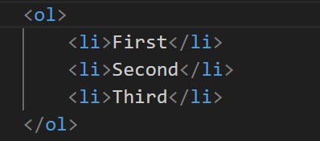

**2 . Unordered Lists (<ul>):**

* Unordered lists are used to present items in a bulleted list format.
* Each item in the list is preceded by a bullet point by default.
* The <ul> element is used to create an unordered list, and each item within the list is defined by the <li> element.

Example:

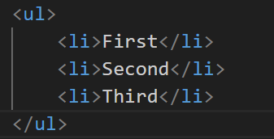

**3. Definition list:**

* Definition lists are used to present terms and their corresponding definitions or descriptions.
* Each term within the list is defined by the <dt> (definition term) element, and each description is defined by the <dd> (definition description) element.
* Unlike ordered and unordered lists, definition lists do not have a specific marker for each item.

Example:

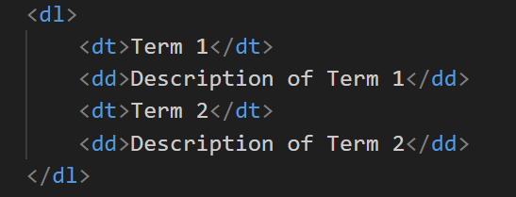

**Ques - 6) What is the ‘class’ attribute in HTML?**

**Ans - 6)**

In HTML, the class attribute is used to assign one or more class names to an element, allowing the element to be styled or manipulated using CSS (Cascading Style Sheets) or JavaScript.

The class attribute does not affect the semantics or functionality of the HTML element itself but provides a way to target and style elements with specific characteristics.

we can assign one or more class names to an HTML element using the class attribute. Multiple classes are separated by spaces.

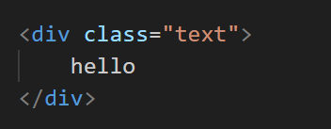

**Ques – 7) What is the difference between the ‘id’ attribute and the ‘class’ attribute of HTML elements?**

**Ans)** The id attribute and the class attribute in HTML serve different purposes and have distinct characteristics**:**

1. Id Attribute:

* The id attribute is used to uniquely identify a single HTML element within the document.
* Each id value must be unique within the HTML document. No two elements can have the same id attribute value.
* It is often used to target specific elements for styling with CSS or for manipulation with JavaScript.
* Commonly used for elements that are unique within the document, such as headers, footers, or important sections.

Example:

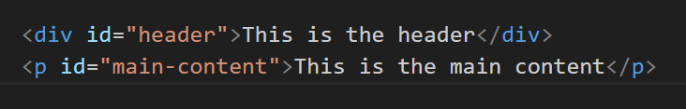

1. Class Attribute:

* The class attribute is used to categorize elements and group them together based on shared characteristics or styles.
* Multiple elements can share the same class attribute value, and an element can have multiple class names separated by spaces.
* It is used to apply CSS styles or JavaScript behaviours to multiple elements that share common traits.
* Often used for styling elements with similar appearances or functionalities.

Example:

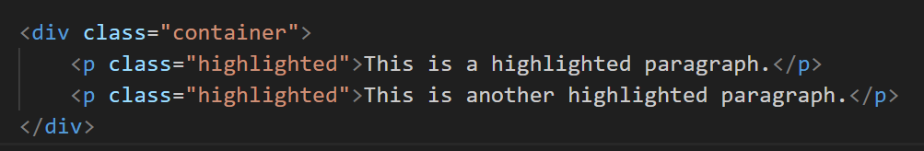

**Ques – 8) What are the various formatting tags in HTML?**

**Ans)** HTML provides various formatting tags that allow you to structure and style content within a web page. Some of the commonly used formatting tags in HTML include:

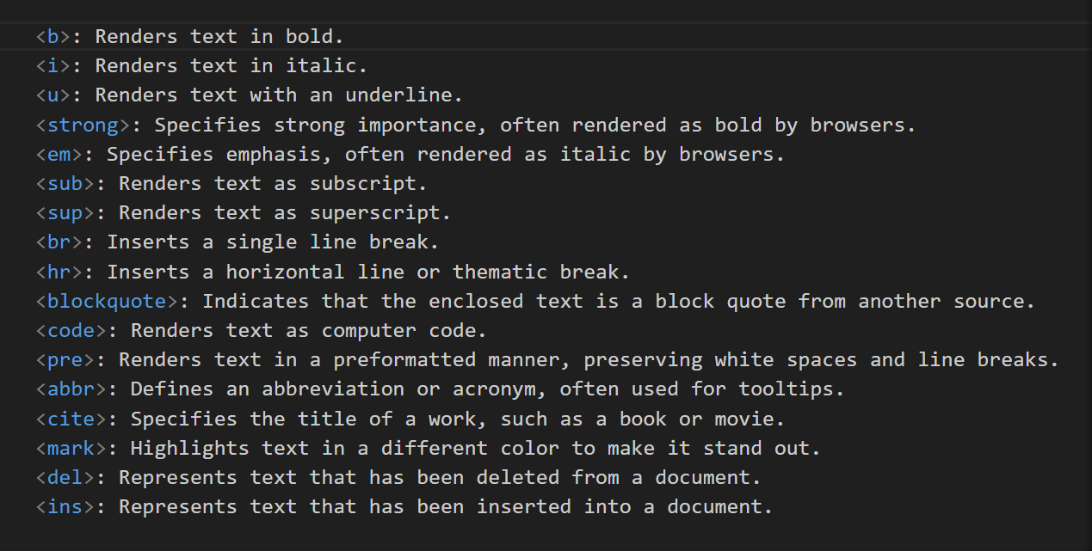

Ques – 9) How is Cell Padding different from Cell Spacing?

Ans) 1.Cell padding:

* Cell padding defines the space between the content of a table cell and the cell's borders.
* It controls the amount of space between the content of the cell and the cell's edges.
* Cell padding is set using the cellpadding attribute within the <table> tag.
* You can specify the padding in pixels or as a percentage of the cell's width.

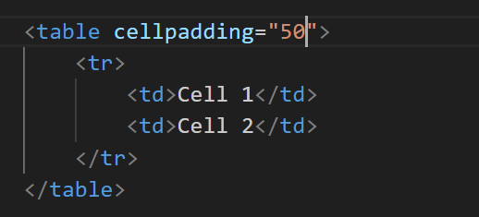

2) Cell spacing:

* Cell spacing defines the space between adjacent cells within the table.
* It controls the distance between the borders of neighbouring cells.
* Cell spacing is set using the cell spacing attribute within the <table> tag.
* Like cell padding, you can specify cell spacing in pixels or as a percentage of the table's width.

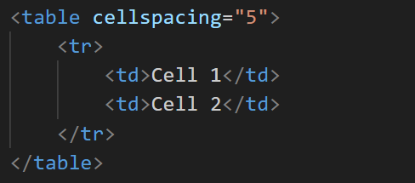

**Ques 10)How can we club two or more rows or columns into a single row or column in an HTML table?**

Ans) We can club two or more rows or columns into a single row or column using row span and column span

**Row span** attribute is use to merge multiple row into single row.

The row span attribute specifies the number of rows that the cell should span.

Example:

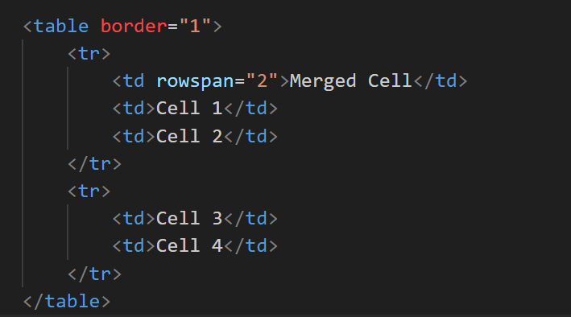

**Column span** attribute is use to merge multiple column into single column.

The Column span attribute specifies the number of rows that the cell should span.

Example:

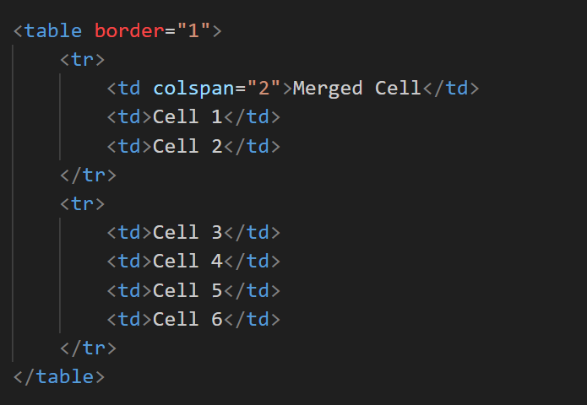

Ques 11) **What is the difference between a block-level element and an inline element?**

Ans)

1. **Block-level Elements:**

* Block-level elements typically start on a new line and occupy the full width available to them.
* They create a "block" of content within the document flow.
* Examples of block-level elements include <div>, <p>, <h1> to <h6>, <ul>, <ol>, <li>, <table>, <form>, etc.
* Block-level elements can contain other block-level elements and inline elements.
* You can apply width, height, margin, padding, and border properties to block-level elements.

1. **Inline Elements:**

* Inline elements do not start on a new line. They flow within the content and typically only take up as much width as necessary.
* They are used for smaller elements within a block of text, such as spans of text, images, links, or other inline elements.
* Examples of inline elements include **<**span>, <a>, <img>, <strong>, <em>, <i>, <b>, <u>, <br>, <input>, etc.
* Inline elements cannot contain block-level elements, but they can contain other inline elements.
* You cannot apply width, height, margin-top, margin-bottom, padding-top, padding-bottom, or border properties to inline elements. However, you can apply margin-left, margin-right, padding-left, padding-right, and border properties.

**Ques 12) How to create a Hyperlink in HTML?**

Ans). Link to visit YouTube Home page:



**Ques 13) What is the use of an iframe tag?**

Ans) The **<iframe>** tag in HTML is used to embed another HTML document within the current document. It allows you to display content from another source, such as a different webpage, in a designated area of your webpage.

Key points about **<iframe>**:

1. **Embedding Content:** It embeds content from another source into the current HTML document.
2. **Displaying External Content:** You can display external webpages, documents, videos, maps, and more.
3. **Independent Document:** The content within the **<iframe>** is independent and behaves like a separate HTML document.
4. **Size and Position:** You can specify the size and position of the **<iframe>** within your webpage.
5. **Scrolling:** You can control whether scrollbars appear if the content within the **<iframe>** exceeds its dimensions.



**Ques 14) What is the use of a span tag? Explain with example?**

**Ans)** The <span> tag in HTML is used to apply styling or scripting to a specific section of text within a larger block of content. It is an inline element and does not create a new line or block-level structure.

Here's how the <span> tag is used:

1. Styling Text: You can use the <span> tag to apply CSS styles, such as colour, font size, font weight, etc., to a specific portion of text without affecting the surrounding content.
2. Scripting: You can use JavaScript to manipulate or interact with specific sections of text within a larger block of content by targeting them using the <span> tag.

Example:



**Ques – 15)How to insert a picture into a background image of a web page?**

Ans)

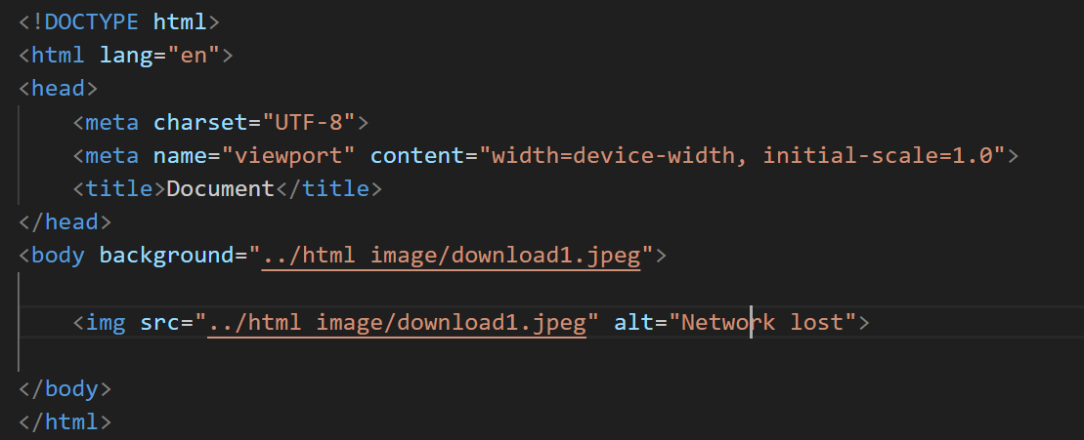

**Que 16) How are active links different from normal links?**

Ans) 1 .**Normal Links:**

* + Normal links, also known as static links, are the default state of links on a webpage.
  + They are displayed and behave as expected, typically directing users to another webpage or resource when clicked.
  + Normal links do not change appearance or behavior based on user interaction, such as hovering or clicking.

1. **Active Links:**
   * Active links are links that have been clicked but have not yet finished loading the target page.
   * The active state occurs immediately after a user clicks on a link and lasts until the target page has fully loaded or the user navigates away from the current page.
   * In some cases, browsers may display a loading indicator or change the appearance of the link to indicate that it is in an active state.
   * Active links provide immediate feedback to users that their click has been registered and that the browser is in the process of navigating to the target page.

**Ques – 17) What are the different tags to separate sections of text?**

**Ans)** Different tags to Separate section:

* 1. **Paragraphs (<p>):** Used to define paragraphs of text.
  2. **Headings (<h1>, <h2>, <h3>, <h4>, <h5>, <h6>)**: Used to define headings of different levels.
  3. **Divisions (<div>)**: Used to group content together for styling or scripting purposes.
  4. **Spans (<span>)**: Used to apply styles or scripting to inline elements within a block of text.
  5. **Sections (<section>)**: Used to define thematic sections within a document.
  6. **Articles (<article>)**: Used to define self-contained articles within a document.
  7. **Lists (<ul>, <ol>, <li>)**: Used to create lists of items, either unordered or ordered.

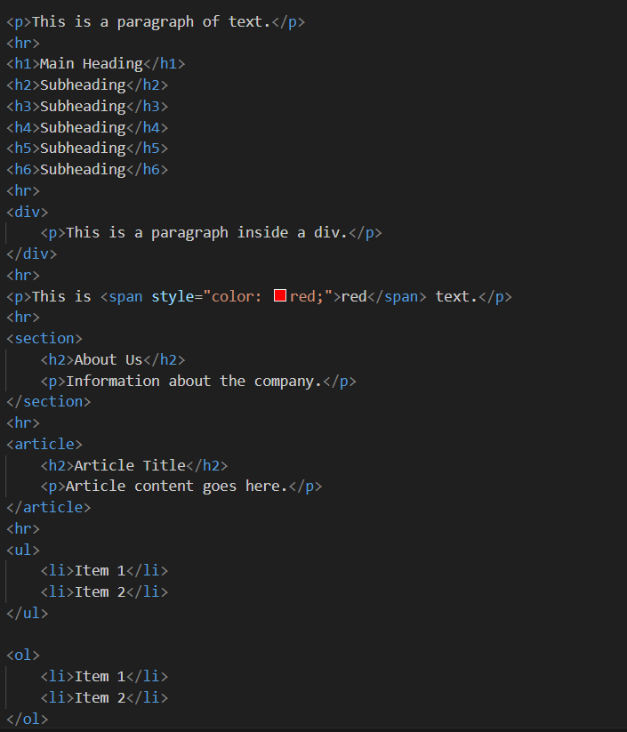

**Ques- 18) What is SVG?**

**Ans) SVG stands for Scalable Vector Graphics**

* SVG is used to define vector-based graphics for the Web
* SVG defines graphics in XML format
* Each element and attribute in SVG files can be animated
* SVG is a W3C recommendation
* SVG integrates with other standards, such as CSS, DOM, XSL and JavaScript
* SVG has elements and attributes for rectangles, circles, ellipses, lines, polygons, curves, and more.
* SVG also supports filter and blur effects, gradients, rotations, animations, interactivity with JavaScript, and more.
* A simple SVG document consists of the <svg> root element and several basic shape elements that will build a graphic together.

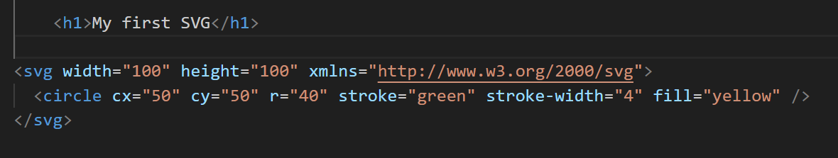

**Ques – 19) What is difference between HTML and XHTML?**

| **HTML** | **XHTML** |
| --- | --- |
| HTML stands for Hypertext Markup Language. | XHTML stands for Extensible Hypertext Markup Language. |
| It was developed by Tim Berners-Lee. | It was developed by W3C i.e World Wide Web Consortium. |
| It was developed in 1991. | It was released in 2000. |
| It is extended from SGML. | It is extended from XML and HTML. |
| The format is a document file format. | The format is a markup language. |
| All tags and attributes are not necessarily to be in lower or upper case. | In this, every tag and attribute should be in lower case. |
| Doctype is not necessary to write at the top. | Doctype is very necessary to write at the top of the file. |
| It is not necessary to close the tags in the order they are opened. | It is necessary to close the tags in the order they are opened. |
| While using the attributes it is not necessary to mention quotes.  For e.g. <Geeks>. | While using the attributes it is mandatory to mention quotes.  For e.g. <Geeks=”GFG”>. |
| Filename extension used are .html, .htm. | Filename extension are .xhtml, .xht, .xml. |
| Lewd structure is used in HTML | It contains a very strict structure |

**Ques-20) What are logical and physical tags in HTML?**

**Ans) Logical Tags:**

Logical Tags are used in Html to display the text according to the logical styles. Following are the logical tags commonly used in HTML.

Tags and description:

<abbr> = Defines an abbreviation

<acronym> = Defines an acronym

<Address> = Defines an address element

<cite> = Defines citation

<code> = Defines computer code text

<blockquote> = Define a long quotation

<pre> = defines preformatted

<strong> = Define strong text

<var> = Defines a variable

**Physical tags:**

Physical Tags are used in HTML to provide actual physical formatting to the text. Following are the Physical tags commonly used in HTML.

Tags and description:

<b> = Defines Bold text

<big> = Defines Big text

<i> = Defines italic text

<small> = Defines small text

<sup> = Defines superscripted text

<sub> = Defines subscripted text